SYSTEM IDENTIFICATION
参考视频：研究生课程｜系统辨识全 77 讲：从测量数据到数学模型（UCCS ECE5560 · 中文字幕）_哔哩哔哩_bilibili
华中科技大学 人工智能与自动化学院 人工智能启明2501班 宋润

目录
1.1背景概念 2
1.2 吹风机Dryer实例 4
2.1 Continuous-time linear time-invariant systems 5

1.1背景概念
10.16.2026
- Box
- White box(transparent透明box):the dynamics of a system for which a lot of information is known a priori. Unknown parameters can be measured directly.
- Black box:
- Gray box(translucent 半透明box):
- Don’t estimate what you know
- This course looks at input-output models. Attach sensors to those internal variables, and then they would become outputs.
- The second “collect data” has different noise, to avoid that the model fits noise really well but is awful
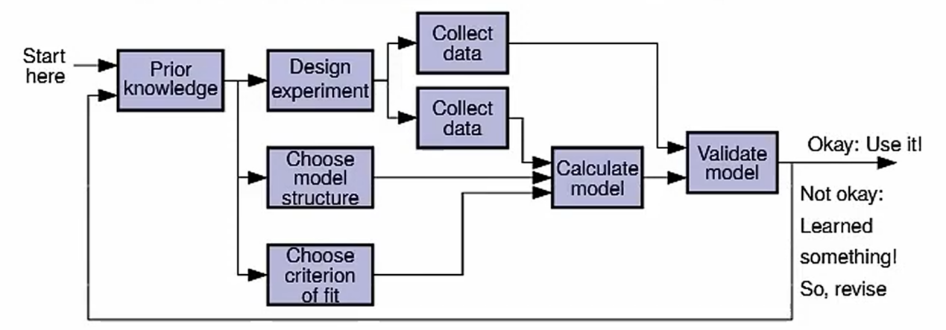
Validate验证
- Some issues with experiment design:
- Open loop or closed loop开环/闭环辨识
- What is the input sequence?
Frequency content , Actuator执行器 limits
- What sampling rate and data length (memory)?
Depending a lot on the frequency response频率响应
- Date Filtering筛选:Must deal with drifts漂移 , biases偏差 , outliers异常值 ; attenuate抑制 noise.
- Some issues with model structure:
- NON-PARAMETRIC: Frequency response plot, or impulse脉冲 response (simplest but poorest , most computation) (参数数量不确定)
- PARAMETRIC:
- System class: linear or nonlinear
- Model size: number of pole极点and zeros of system transfer function and disturbance transfer function. Also, how many delays between input and output?
- Some issues with fitting the model:
- big tradeoff between accuracy and ease of solution
- Significant degree of user input required
- Some issues with validation:
- Different date sets (split it in half if you have only one set)
- Time- and frequency-domain analysis
- Stochastic随机的 analysis of the residual残差error
- Does result imply that we should make changes to:
Experiment (input sequence),
Model choice (order, type.,...),
Objective function for fit,
Optimization procedure

1.2 吹风机Dryer实例
10.17.2026
- PRBS : Pseudo-random binary sequence伪随机二进制序列.
- Bode plot : A Bode plot shows frequency response with two logarithmic对数的 curves: magnitude幅值 (gain in增益 dB vs frequency) and phase相位 (degrees vs frequency).
- Inverse逆

2.1 Continuous-time linear time-invariant systems
10.18.2026
- linear time-invariant (LTI)线性时不变
- Test a system if it is a LTI system
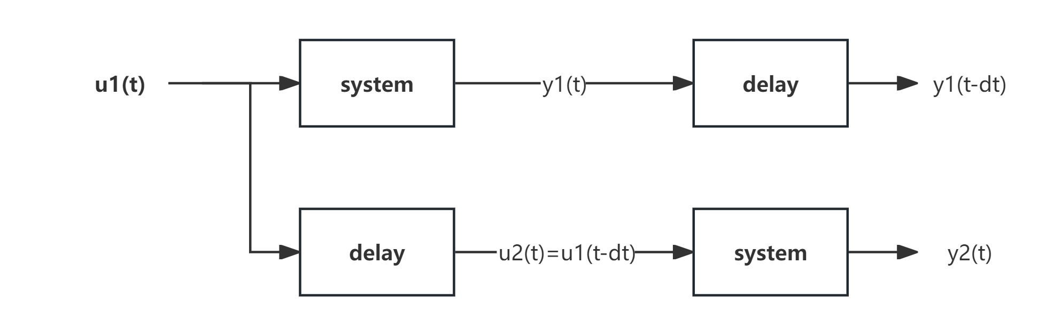
A time-invariant system will have y2(t) = y1(t - dt) for all u1(t) and dt.
- “delay operator”
$y(t)=u(t−λ) , λ≥0.$
- LINEAR
For linear systems, if $u_{1}(t)↦y_{1}(t)$ and $u_{2}(t)↦y_{2}(t)$, the
$$u_{3}(t)=αu_{1}(t)+βu_{2}(t)↦y_{3}(t)=αy_{1}(t)+βy_{2}(t)$$
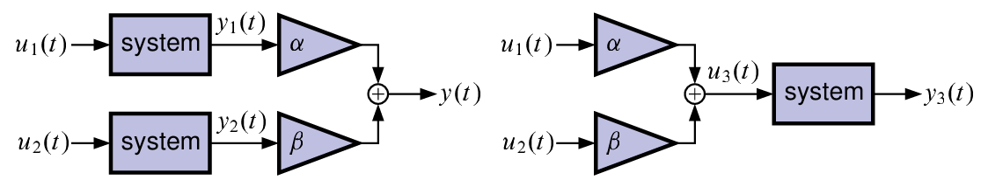
- LTI system has an impulse response冲激响应 , which entirely characterizes the system’s dynamics
- The Fourier transform of the impulse response is the frequency response.
- The Laplace transform of the impulse response is the transfer function.
- Lumped LTI systems can also be represented in state-space form.
- Lumped 集总（反义词是分布Distributed）
